PLAT PREAPPROVAL PROCESS
Application Deadline & Completeness: All required application information and payment of the application fee must be received by the deadline identified on the Mission Township schedule.
All applications are evaluated by Mission Township’s Zoning Administrator as well as Planning Commission Board Members. Review includes the application form, fee, site plan, and other relevant supporting information. If the materials submitted are deemed to be incomplete, the Zoning Administrator may reject the application and not place the item on the Planning Commission agenda.
Application Fees:
Minor Preliminary Plat Review: | All Zoning Districts | $150 + $20 per lot
Major Preliminary Plat Review: | All Zoning Districts | $300 + $20 per lot
Other Review: | All Zoning Districts | At an hourly rate of $150
Development Escrow: | All Zoning Districts (when Applicable) | $3,000 or as Defined in Development Agreement

Application Information Required: Two full-sized copies (24”x36”) of the plat (one copy sent to Mission Township and one copy sent to Zoning Administrator) and an electronic version sent to the Zoning Administrator.
- A Development Review Team (DRT) will need to be held prior to the Mission Township Planning Commission meeting. Applicant must contact Crow Wing County to set up the DRT meeting. Applicant is responsible for notifying the Zoning Administrator of this request.
- If the property being platted has roadway dedications, stormwater facilities, or other proposed public land dedication to Mission Township, Developer must enter into a developer’s agreement with the Township. The developer’s agreement will need to be reviewed and approved by the Town Board. Any costs incurred for creation or review of the agreement by the Township’s Attorney will be passed on to the developer.
- If the property being platted has roadway dedications to Mission Township, Developer must follow the Road Standards of the Township. The plat submittal will need to be reviewed and approved by the Town Board. Any costs incurred for review of the Road Standards by the Township’s Engineer will be passed through to the developer.
- The proposed development and plat must be in harmony of Mission Township’s Comprehensive Plan.
- Once a determination is given from Mission Township, the applicant is responsible for submitting an application and plat documents to Crow Wing County per the County’s requirement and process. Documentation of approval from the Township shall be provided in addition to the application documents required by the County. The application MUST be submitted to the Township prior to Crow Wing County. Applicant is responsible for notifying the Zoning Administrator of this request.

Zoning Administrator Review: Zoning staff will review all application materials and prepare a memorandum for the Planning Commission. The memo will contain Township staff’s recommendation to approve, approve with conditions, or deny. A copy of all application materials, including the staff memo, will be available to the applicant prior to the Planning Commission meeting. All materials will be available to the public through a request to the Mission Township’s Clerk.
Planning Commission Meetings: Planning Commission meetings are held on the second Monday of each month as needed, unless there is a conflict with an election or holiday.
- The Planning Commission receives a copy of all plat application materials and the report from the Zoning Administrator a minimum of 4 days prior to the meeting.
- The Planning Commission may ask the applicant to answer questions related to the proposed plat and may elect to hold a public hearing on any application.
- The Planning Commission has the option of recommending approving of the request, recommending approving of the request with conditions, recommending denial of the request, or tabling a recommendation on the matter to their next meeting. The Planning Commission's decision is submitted to the Town Board in the form of a recommendation, along with application materials, a copy of the staff report and recommendation, and any other related information. All the submitted information creates the ‘public record’ and is kept on file with the Township Clerk.
Town Board Meetings: Township Board meetings are held immediately after the Planning Commission meeting on the second Monday of each month unless there is a conflict with an election or holiday.
- The Town Board does not hold a public hearing but may ask the applicant to answer questions related to the proposed plat.
- The Town Board has the option of approving the request, approving the request with conditions, denying the request, or tabling a decision on the matter to their next meeting.
Plat Preapproval Flowchart Process
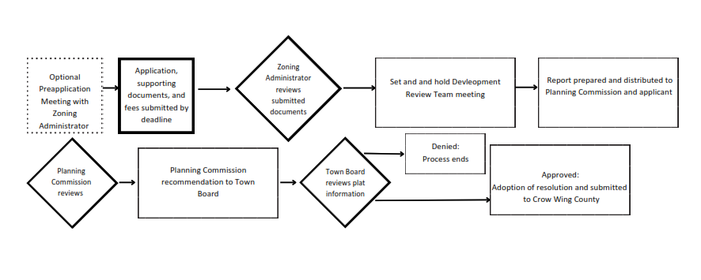_____________________________________________________________________________________

Note to Applicant: Please be aware that any written information you provide with your application becomes the property of Mission Township. All comments made at all meetings of the Development Review Team Meeting, Planning Commission, and Township Board become part of the public record.
Questions/Submit Completed Application To:
Zoning Administrator:
Saehr Consulting (Providing Services to Mission Township)
Scott Saehr, Community Planning and Zoning Director
Phone: (320) 260-2042
Email: scott.saehr@saehrco.com

Mission Township Clerk
29474 County Road 3
P.O. Box 126
Merrifield, MN 56465
Phone: 218-765-4377
Email: missionclerk@gmail.com
Website: missiontownship.org

Acknowledgment:
I fully understand that submitting the above information is required for preapproval of a plat in Mission Township.

Applicant’s Signature: ___________________________________ Date: ______________

